Handling sensitive information, such as passwords, in Terraform state files requires careful management to ensure security. Terraform state files can contain plaintext sensitive data, so it's crucial to implement best practices to mitigate risks. Here are some strategies:

**1. Use Sensitive Variables**

Mark variables containing sensitive information as sensitive in your Terraform configuration. This ensures that Terraform does not log their values or display them in the console output.

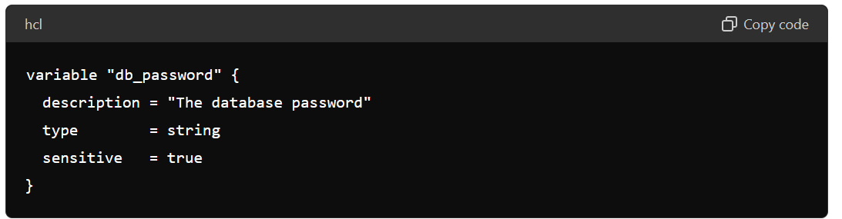

### 2. Store State Files Securely

Use a remote backend to store your Terraform state files. Remote backends, such as AWS S3 with encryption, Azure Blob Storage, or HashiCorp's Terraform Cloud, provide secure storage and access controls.

#### 

### 3. Use Environment Variables for Sensitive Data

Avoid hardcoding sensitive data in your Terraform configuration files. Instead, use environment variables and reference them in your configuration.

#### Example:

Set the environment variable:

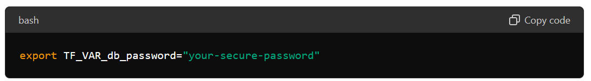

Reference the environment variable in your Terraform configuration:

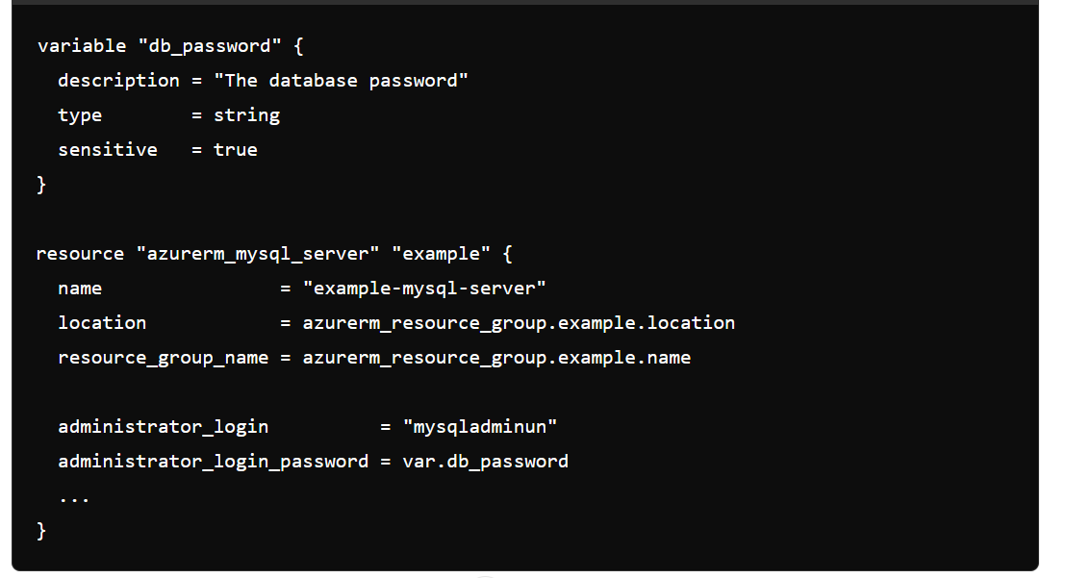

**4. Encryption at Rest and in Transit**

Ensure that your state files are encrypted both at rest and in transit. Most remote backends support this natively.

* **AWS S3**: Enable default encryption and use SSL/TLS for secure data transfer.
* **Azure Blob Storage**: Enable encryption and use HTTPS for secure data transfer.
* **Terraform Cloud/Enterprise**: State is automatically encrypted at rest and in transit.

**5. Limit Access to State Files**

Control who can access your Terraform state files by implementing strict access controls (IAM policies, role-based access controls, etc.) on your remote backend.

**6. Secrets Management Tools**

Use dedicated secrets management tools, such as HashiCorp Vault, AWS Secrets Manager, or Azure Key Vault, to securely manage and inject sensitive data into your Terraform configurations.

### 7. Rotate Secrets Regularly

Regularly rotate your secrets and update them in your Terraform configurations and state files to minimize the risk of compromised credentials.

### Summary

By marking variables as sensitive, using secure remote backends, environment variables, encrypting state files, limiting access, leveraging secrets management tools, and rotating secrets, you can securely handle sensitive information in Terraform state files. Implementing these best practices ensures that your sensitive data remains protected throughout the infrastructure lifecycle.